2022

Analyses of Credit card Data in SQL

*Shubham Kava*

*90167 42225 kavashubham1998@gmail.com*

*Executive summary*

Analysis on credit card data of customers from several category perspectives. use certain criteria to filter client data and get some useful information from the data.

1. **Do you know how to import data in SQL?**

Answer: - Create a server and connect data to it. “SQL”

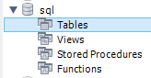

In a SQL server, we will import data in Table using Table data Import Wizard as shown in the image below.

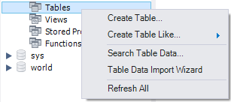

Enter the path and select the CSV file of our dataset.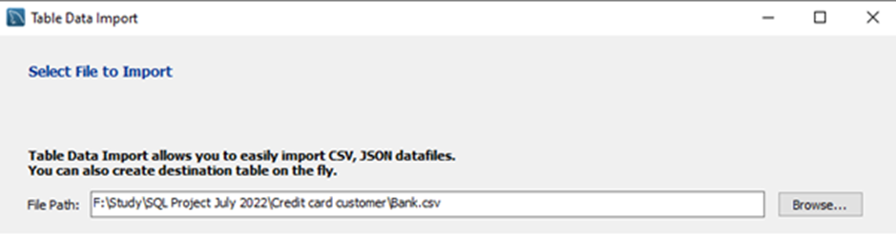

If you want to update the data set in an existing table then select 1st bullet or if you want to create a new table select the server in which you want to create the table and then mentioned the table name.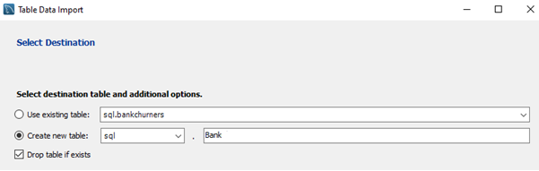

Select the column and then select Data type accordingly click next.

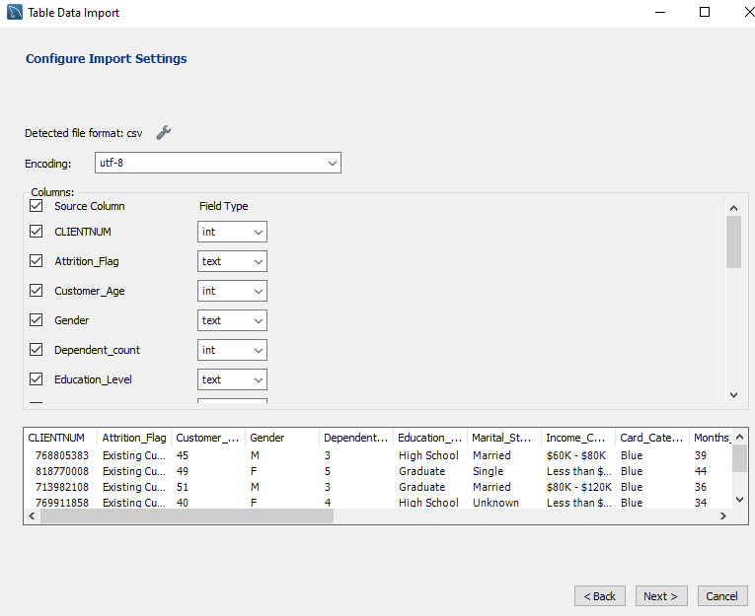

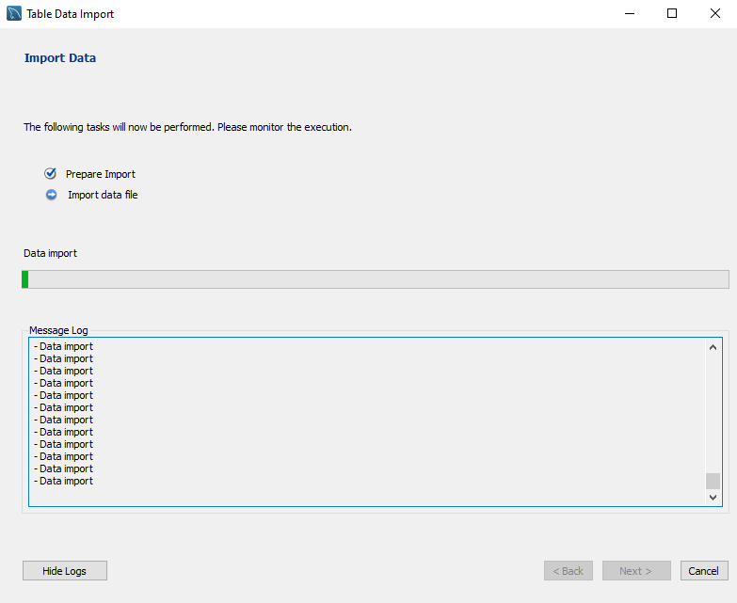

A large dataset can take time to import data.

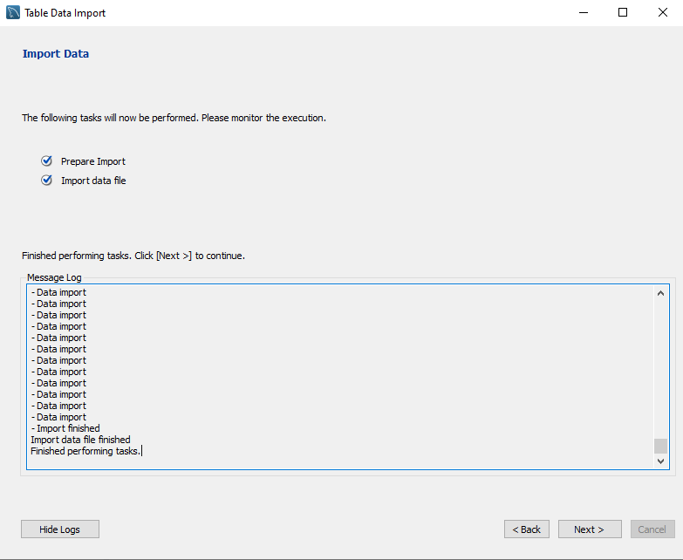

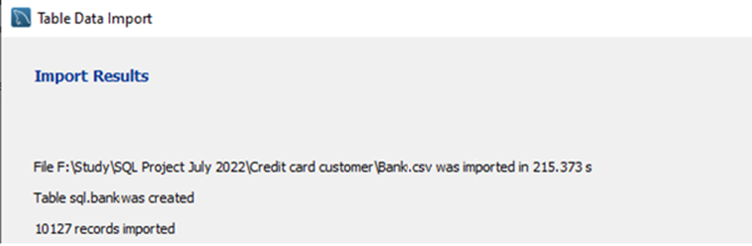

How many records are imported we can see in the import result.

After importing data into SQL, we will see what the data looks like.

* Let's look forward to the types of data in our dataset.
  + In the dataset, there are some categorical columns like Education, Marital status, and Card category.
  + Also, we have some Boolean types of columns like Attrition Flag and Gender.
  + Numerical columns are Customer Age, Credit Limit, Total Revolving Balance, Average open to buy, etc.
* There are some important factors in our dataset, a combination of them can help us in the analysis and get important information inside the data then we can take an important business decision.
  + As
* The male and the female ratio in our dataset.
  + Male: - 0.4709
  + Female: - 0.5291
* How many customers are from different educational backgrounds?
  + There are 1487 clients from the Uneducated Group.
  + Customers from a High School Group are in 2013.
  + There are 1013 clients in the collegiate group.
  + The number of Graduate Group clients is 3128.
  + There are 516 consumers from the postgraduate group.
  + There are 451 clients in the Doctorate Group.
  + The educational backgrounds of 1519 customers are unknown to us.

1: - In our dataset, there are some group customers with higher income and good credit limits and age them also lower but they use low credit cards?

Answer: - First check whether the consumers in groups that earn more and their credit limit.

Run the below code in SQL to get a result.

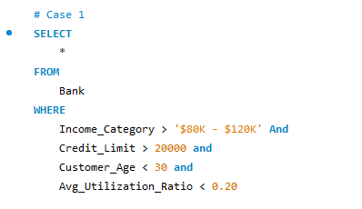

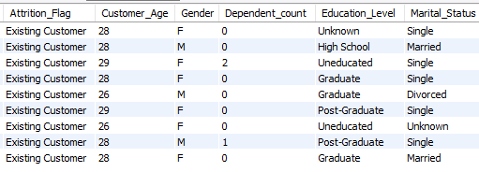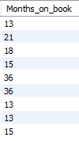

Based on the above customer list we can ask them for the new scheme for more usage of cards and benefits of it at different levels based on usage.

* Most of the customers are under the blue card category
* In this group of 6 females most of the females are single and 3 males.
* Customer age is between 26 to 29
* 3 customers are 1 year old and 2 customers are 3 years of relation with us.

2: - Select customer data with their age is between 30 to 35 with a credit limit of more than 18,000 and Inactive last two years and lower credit card usage.

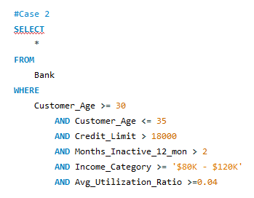

After running the above code in SQL, we get the below-filtered data.

Based on it let's look inside the data.

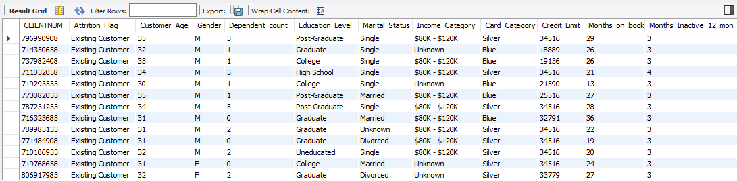

* In this case, all are Existing Customers
* Most of the customers are male and more dependent people.
* People are highly using silver card
* most of the customers have 2 years of relation with us.

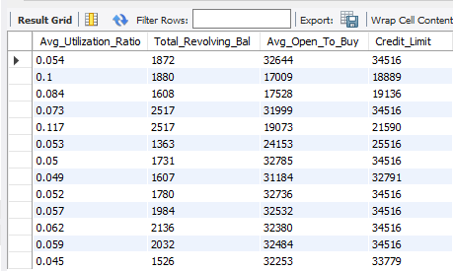

* Based on their credit limit, the overall utilization ratio of this group of customers is near 0.065.

3: - Check the customers earning more them $120K or they are our 4 years old customers and they are not using a credit card.

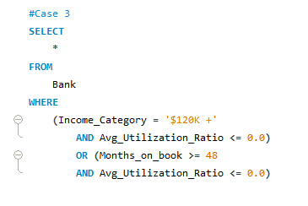

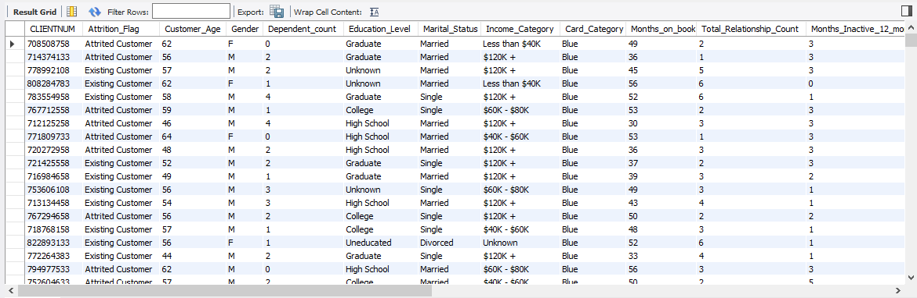

* There are 354 customers, whose earnings are more than $1,20,000 or 4-year-old customers but don’t use a credit card.
* Out of 354 customers, males are higher in comparison to females.
* Most of the customers are not more dependent.
* Most of the customers are single.
* The highest card usage category is Blue.

4: - Let's look at the database on Marital Status and people's Average Utilization Ratio

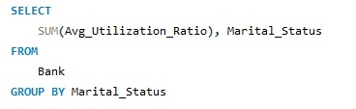

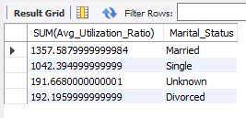

Some customers did not mention their marital status.

Based on information received from customers, Married customers' average utilization of their credit is the highest, there is little difference (316) between single and Married customers' average utilization.

Divorced customers utilize their credit is too lowest.

5: - Let’s check the ratio between Existing Customers and attired Customer

* Existing Customers: -

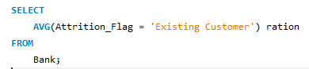

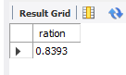

The average number of Existing customers is 83.93 %.

* Attired Customer: -

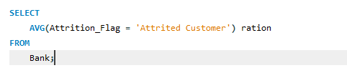

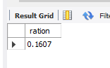

Average attired customers are 16.07 %

6: - Let's look at the database on Education Level people's Average Utilization Ratio

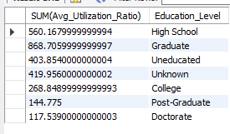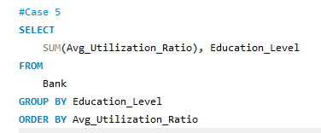

In our dataset, graduates are utilizing the highest credit limits.

Lowest credit utilized by doctors.

7: - Customer age spending

For finding out customer age spending, we have summed the transaction amount based on customer age.

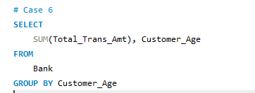

Let’s check the output of our query of SQL.

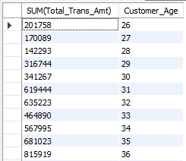

The age group from 26 to 30 is spending their money between 1,40,000 to 3,50,000. Out of that lowest spending age group of a customer is 28 and highest spending 30. Almost 250 % increase of spending, in compare of 5 years of change in an age of the customer.

Age from 31 to 35 is spending thor money more than 4,64,000 and less than 6,82,000. Customers aged 33 are spending the lowest and the highest age at 35.

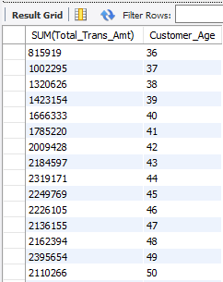

Customer age from 36 to 40, they are spending between 16,67,000 to 8,00,000. age group, in this case, is increasing the spending when age is increasing.

The age of customers increases from 41 to 50, their spending is not the highest increase more compare it with age. This age group spending between 17,85,000 to 24,00,000.

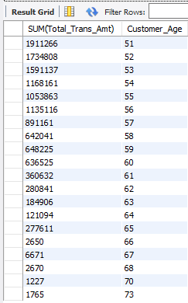

Customers aged from 51 to 56 are still spending amounts between 10 lakhs to 20 lakhs.

After the 56 to 65 age of customers spending from 2,77,000 to 9,00,000.

The highest age of customer age spending is 49 and the lowest is 73.

Case 8: - Based on income category

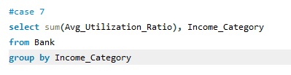

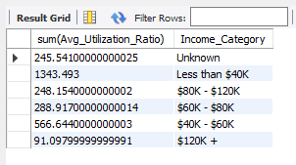

In the top income category, customers' average utilization ratio is the lowest and lowers income category customers’ average utilization ratio is the highest.

*Thank You*